One-Way ANOVA – Example 3 (Jurors’ Perceptions) – Answer Key

A social psychologist is interested in determining whether knowledge of a defendant’s previous criminal record influences the juries’ perceptions of the guilt or innocence of defendants. The researcher recruits 15 volunteers who have been selected for jury duty (but have not yet served at a trial). The participants are randomly assigned to one of three groups. All of the research participants are given a “background sheet” with age, marital status, education, and other demographic information about a woman accused of passing bad checks. The sheet is the same for all three groups, with one difference. For the criminal record group, the last section of the sheet says that the woman has been convicted several times before of passing bad checks. For the clean record group, the last section of the sheet says the woman has a completely clean criminal record. For the no information group, the sheet does not mention anything about a criminal record. The researcher shows all participants a video of a 4-hr trial in which a woman is accused of passing bad checks. After viewing the tape of the trial, participants rate her level of guilt on a 10-point scale, ranging from 1 (sure she is innocent) to 10 (sure she is guilty). The data are shown in the table.

Step 1. State your hypotheses.
a. Hypotheses in words:
H_{A}: There is at least one difference among the ratings of guilt given by the criminal record, clean
record, and no information groups.

H₀: There is no difference among the ratings of guilt given by the criminal record, clean record,
and no information groups.

b. Hypotheses in symbols:
H_{A}: not all μs are equal

H₀: μ_{criminal record} = μ _{clean record} = μ _{no info}

Step 2. Set the significance level ➔ α = .05 Determine F_{crit}. F_{crit} = __3.88___
df_{between} = 2 df_{within} = 12

df_{between} = k – 1 df_{within} = N_{tot} – k df_{tot} = N_{tot} – 1 df_{tot} = df_{between} + df_{within}
= 3 – 1 = 15 – 3 = 15 – 1 = 2+ 12
= 2 = 12 = 14 = 14

Step 3. Select and compute the appropriate statistic and then complete the source table.
Criminal Record  X₁ | Clean Record  X₂ | No Info  X₃
10 | 5 | 4
7 | 1 | 6
5 | 3 | 9
10 | 7 | 3
8 | 4 | 3
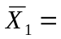8 | 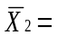4 | 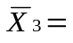5

SS_{tot}= ∑(X - M_{tot})²

X₁ M_{tot} X-M_{tot} (X-M_{tot})²
10 5.67 4.33 18.75
7 5.67 1.33 1.77
5 5.67 -.67 .45
10 5.67 4.33 18.75
8 5.67 2.33 5.43
X₂
5 5.67 -.67 .45
1 5.67 -4.67 21.81
3 5.67 -2.67 7.13
7 5.67 1.33 1.77
4 5.67 -1.67 2.79
X₃
4 5.67 -1.67 2.79
6 5.67 .33 .11
9 5.67 3.33 11.09
3 5.67 -2.67 7.13
3 5.67 -2.67 7.13
SS_{tot} = 107.35

SS_{within}= ∑(∑(X – M_{group})²)

X₁ M₁ X₁-M₁ (X₁-M₁)² X₂ M₂ X₂-M₂ (X₂-M₂)²
10 8 2 4 5 4 1 1
7 8 -1 1 1 4 -3 9
5 8 -3 9 3 4 -1 1
10 8 2 4 7 4 3 9
8 8 0 0 4 4 0 0
∑(X₁-M₁)² = 18 ∑(X₂-M₂)² = 20

X₃ M₃ X₃-M₃ (X₃-M₃)²
4 5 -1 1
6 5 1 1
9 5 4 16
3 5 -2 4
3 5 -2 4
∑(X₃-M₃)² = 26 SS_{within} = 18 + 20 + 26 = 64
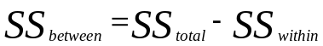
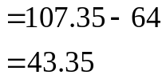

Source | SS | df | MS | F
Between | 43.35 | 2 | 21.68 | 4.07
Within | 64 | 12 | 5.33
Total | 107.35 | 14 |  | F_{crit} = 3.88

Step 4. Make a decision. Determine whether the value of the test statistic is in the critical region. Draw a picture. Label F_{crit} and F_{obt}. Is F_{obt} in the critical region? ___yes____
Is F_{obt} in the critical region? ___yes_____
Should you reject or retain the H₀? reject

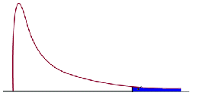
F_{crit} = 3.88
F_{obt} = 4.07

Step 5. Report the statistical results.

F(2,12) = 4.07 p < .05

Step 6. Write a conclusion.

The means of the Criminal Record, Clean Record, and No Information groups are 8, 4, and 5, respectively. The ANOVA revealed a significant difference among the groups in ratings of guilt, F(2,12) = 4.07 p < .05.

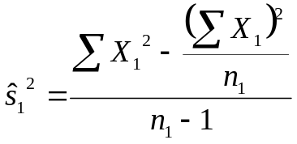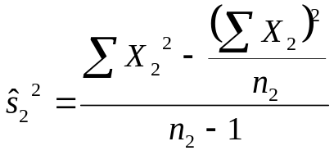Step 7. Compute eta² and write a conclusion.

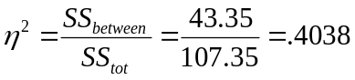

The information provided about the criminal accounted for 40.38% of the variability in the rating of guilt.

